**A Project Report**

**on**

**EXAM BRANCH MANAGEMENT SYSTEM**

**Submitted in Fulfilment of the Requirements for**

**The Award of**

**DIPLOMA IN COMPUTER ENGINEERING**

**Submitted by**

**TEAM MEMBERS**

**S.ANKITH 17047-CM-002**

**M.VISHNU VARDHAN 17047-CM-059**

**V.SAI CHARAN 17047-CM-036**

**T.VIJAY SHEKAR 17047-CM-057**

**B.LOKESHWARI 17047-CM-015**

**S.VINOOTHNA 17047-CM-058**

**Under the esteemed Guidance of**

**Mrs G.SREE MADHURI , B. Tech (M. Tech), Lecturer in Computer Engineering [DCME]**



**S.G.M. GOVERNMENT**

**POLYTECHNIC ABDULLAPURMET**

**R.R. DISTRICT (2019-2020).**

**A Project Report**

**on**

**EXAM BRANCH MANAGEMENT SYSTEM**

**Submitted in Fulfilment of the Requirements for**

**The Award of**

**DIPLOMA IN COMPUTER ENGINEERING**

**Submitted by**

**TEAM MEMBERS**

**S.ANKITH 17047-CM-002**

**M.VISHNU VARDHAN 17047-CM-059**

**V.SAI CHARAN 17047-CM-036**

**T.VIJAY SHEKAR 17047-CM-057**

**B.LOKESHWARI 17047-CM-015**

**S.VINOOTHNA 17047-CM-058**

**Under the esteemed Guidance of**

**Mrs G.SREE MADHURI ,B. Tech(M. Tech), Lecturer in Computer Engineering [DCME]**



**S.G.M. GOVERNMENT**

**POLYTECHNIC ABDULLAPURMET**

**R.R. DISTRICT (2019-2020).**

**DEPARMENT OF TECHNICAL EDUCATION**

**SANJAY GANDHI MEMORIAL GOVERNMENT POLYTECHNIC**

**ABDULLAPURMET,R.R DIST.**

**DIPLOMA IN COMPUTER ENGINEERING**



**CERTIFICATE**

**This is to certify that the these is entitled “EXAM BRANCH MANAGEMENT SYSTEM”**

**being submitted by the TEAM MEMBERS in fulfillment of the requirements for the award of**

**DIPLOMA IN COMPUTER ENGINEERING for the**

**STATE BOARD OF TECHNICAL EDUCATION AND TRAINING,T.S, during the year(2019-2020).**

**The results presented in this thesis have been verified and found to be excellent.**

**PROJECT GUIDEEXTERNAL EXAMINER**

**Mrs .G. SRI MADHURI,B.TECH(M.TECH).**

**HEAD OF DEPARTMENT PRINCIPAL**

**SRI J.SUSHEEL KUMAR JOSHI SRI CH.V.KRISHNA RAO**

**M. Tech ME,MBA,DIS FIE(Ph. D)**

**ACKNOWLEDGEMENT**

It is our privilege and pressure to express our profound sense of respect, gratitude and indebtedness to **SRI CH.V.KRISHNA RAO ME,** MBA,DIS FIE(Ph. D), principal, S.G.M Government Polytechnic, who has helped and guided us by his valuable suggestions.

We express our deep sense of gratitude to **SRI J.SUSHEEL KUMAR JOSHI, M. tech** , Head of the Computer Engineering Department**,** S.G.M Government Polytechnic, for his indefatigable inspiration, guidance, constructive criticisms and encouragement throughout this dissertation work.

We are grateful to our project guide **Mrs .G.SREE MADHURI, B. tech (M. tech)**, lecturer in Computer Engineering Department for the guidance, inspiration and constructive suggestions that helped us in the preparation of this project.

We also thank **Mr. B.VAJRAIAH, M. tech**, senior lecturer in Computer Engineering Department, **Mrs. K.SUNITHA, B.E**, **Mrs. ALEKHYA, B. tech**, lecturer’s in Computer Engineering Department who has helped in successful completion of our project.

The satisfaction that accompanies the successful completion of any task would be incomplete without the mention of the people who made it possible and whose constant guidance and encouragement crown all the efforts with success.

Last but not least, we wish to acknowledge our friends, family members, and colleagues for giving moral strength and helping us to complete this dissertation.

**TEAM MEMBERS**

DEPARTMENT OF COMPUTER ENGINEERING,

S.G.M Government Polytechnic.

**DECLARATION BY THE CANDIDATES**

**We , TEAM MEMBERS here by declare that the project report titled**

**”EXAM BRANCH MANAGEMENT SYSTEM“ Under the guidance of Mrs. G.SREE MADHURI, B. tech(M. tech),Lecturer in Computer Engineering Department, S.G.M.GOVERNMENT POLYTECHNIC ABDULLAPURMET, R .R. District, is submitted in partial fulfillment of the Requirements for the award of DIPLOMA IN COMPUTER ENGINEERING. This is a Record of Bonafide work carried out by us and the results embodied in this project have not been copied or reproduced from any source.**

**The results embodied in this thesis have not been submitted to any other university or institute for the award of any Diploma or Degree.**

**TEAM MEMBERS**

**ABSTRACT:**

The main objective of the project is to provide the examination result to the student in a simple way. The system is intended for the student. And the privileges that are provided to student are to read and execute his/her result by providing user name and password for secure login and in case of new student the registration is available. The whole result analyzer will be under the control of the administrator and the admin as the full privileges to read, write and execute the result. And admin gives the privileges to the student to access the result. The student can share or download his/her result.

**INDEX**

**1. INTRODUCTION**

**1.1 ADMIN FEATURES**

**1.2 STUDENT FEATURES**

**1.3 FUTURE SCOPE**

**2. TECHNOLOGY USED**

**3. UML DIAGRAMS**

**4. TESTING**

**4.1 UNIT TESTING**

**4.2 INTEGRATION TESTING**

**4.3 SYSTEM TESTING**

**5. CONCLUSION**

**INTRODUCTION**

**INTRODUCTION:**

This specification document describes the capabilities that will be provided by the software application EXAM BRANCH MANAGEMENT SYSTEM. It also states the various constraints by which the system will abide. The intended audience for this document are the development team, testing team and end users of the product.

The application will have capability to maintain information about the students enrolled in the course, the subjects offered to students during different semesters, the marks obtained by the students in different subjects in various semesters. The software will also generate summary report regarding student information, semester wise marks list.

**ADMIN FEATURES**

Add Update Display Delete Semesters.

Add Update Display Delete Subjects and their Full Marks.

Create/ Approve/Disapprove student account.

View Results of each student.

Update Records.

**STUDENT FEATURES**

He/she needs to create an account.

Can view their Semester Results for All Subjects.

Generate/Download Report of Results.

**FUTURE SCOPE:**

The application will manage the information about various students enrolled in the course in different years, the subjects offered during different semesters of the course, the marks obtained by the various students in various subjects in different semesters.

The application will greatly simplify and speedup the result preparation and management process.

TECHNOLOGY USED

**HTML:-**

HTML Stands for "Hypertext Markup Language." HTML is the language used to create web pages. "Hypertext" refers to the hyperlinks that an HTML page may contain. "Markup language" refers to the way tags are used to define the page layout and elements within the page.

A web page is a document which is commonly written in HTML and translated by a web browser. A web page can be identified by entering an URL. A Web page can be of the static or dynamic type. It supports various types of text editors.

**CSS: -**

Stands for "Cascading Style Sheet." Cascading style sheets are used to format the layout of Web pages. They can be used to **define** text styles, table sizes, and other aspects of Web pages that previously could only be **defined** in a page's HTML. ... Plus, **CSS** makes it easy to change styles across several pages at once.

**PHP: -**

**PHP**. Stands for "Hypertext Preprocessor." ... **PHP** is an HTML-embedded Web scripting language. This means **PHP** code can be inserted into the HTML of a Web page. When a **PHP** page is accessed, the **PHP** code is read or "parsed" by the server the page resides on.

A lot of the syntax of PHP is borrowed from other languages such as C, Java and Perl. However, PHP has a number of unique features and specific functions as well. The goal of the language is to allow Web developers to write dynamically generated pages quickly and easily. PHP is also great for creating database-driven Web sites. If you would like to learn more about PHP, the official site is [PHP.net](https://www.php.net/).

**JAVA: -**

Java is a high-level [programming language](https://techterms.com/definition/programming_language) developed by Sun Microsystems. It was originally designed for developing programs for set-top boxes and handheld devices, but later became a popular choice for creating web [applications](https://techterms.com/definition/application).

The Java [syntax](https://techterms.com/definition/syntax) is similar to [C++](https://techterms.com/definition/cplusplus), but is strictly an [object-oriented programming language](https://techterms.com/definition/oop). For example, most Java programs contain [classes](https://techterms.com/definition/class), which are used to define objects, and [methods](https://techterms.com/definition/method), which are assigned to individual classes. Java is also known for being more strict than C++, meaning variables and [functions](https://techterms.com/definition/function) must be explicitly defined. This means Java [source code](https://techterms.com/definition/sourcecode) may produce errors or "exceptions" more easily than other languages, but it also limits other types of errors that may be caused by undefined variables or unassigned types.

**MYSQL: -**

MySQL is based on the structure query language ([SQL](https://techterms.com/definition/sql)), which is used for adding, removing, and modifying information in the database. Standard SQL commands, such as ADD, DROP, INSERT, and UPDATE can be used with MySQL.

MySQL can be used for a variety of applications, but is most commonly found on Web servers. A website that uses MySQL may include Web pages that access information from a database. These pages are often referred to as "dynamic," meaning the content of each page is generated from a database as the page loads. Websites that use dynamic Web pages are often referred to as database-driven websites.

**APACHE TOMCAT:-**

**Apache Tomcat** is an open source web **server** that is developed by **Apache** software foundation. It basically make our **Java** Web applications to run on host and **server** based system and it is configured on local host port 8080. It generally runs JSP, Servlet etc. ... It generally runs JSP, Servlet etc.

There are two types of servers.

1.Application Server

2.Web server

Apache Tomcat is an open source web server that is developed by Apache software foundation.

It basically makes our Java Web applications to run on host and server based system and it is configured on local host port 8080.

It generally runs JSP, Servlet etc.

# **Home Page:**

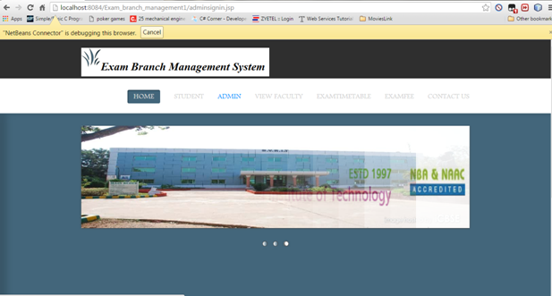

**Figure 1**

**Admin Login page:**

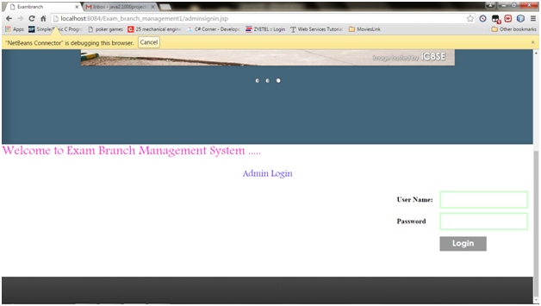

**Figure 2**

**Student Login Page:**

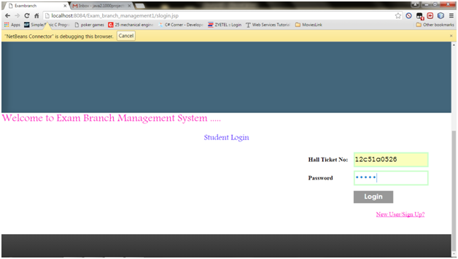

**Figure 3**

**Admin Home Page:**

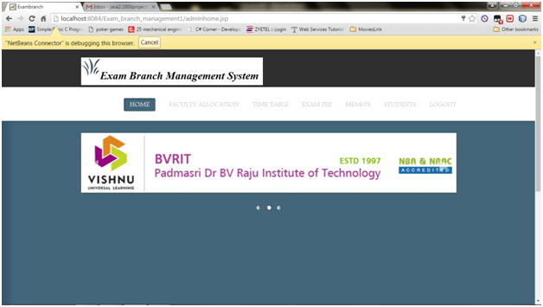

**Figure 4**

**Faculty Allocation Table:**

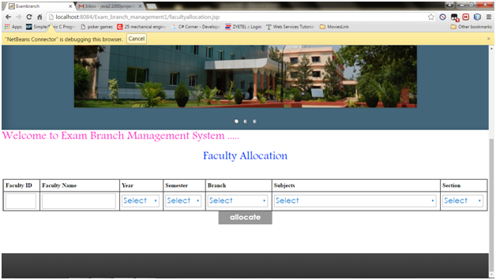

Figure 5

**Add Time Table:**

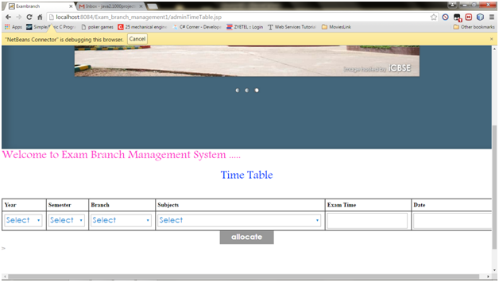

**Figure 6**

Exam Fee Details:

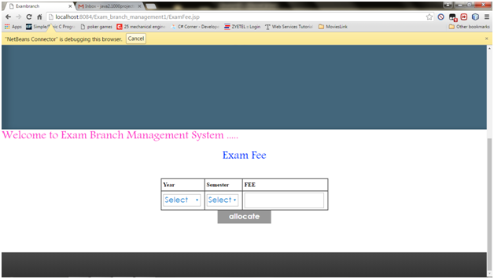

Figure 7

Students Memos:

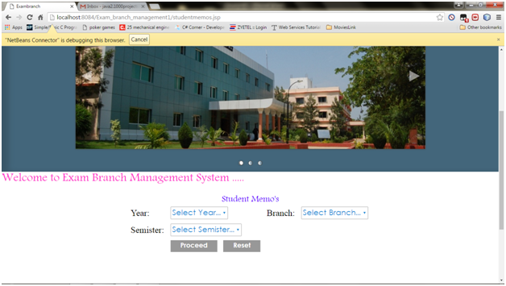

Figure 8

Students List:

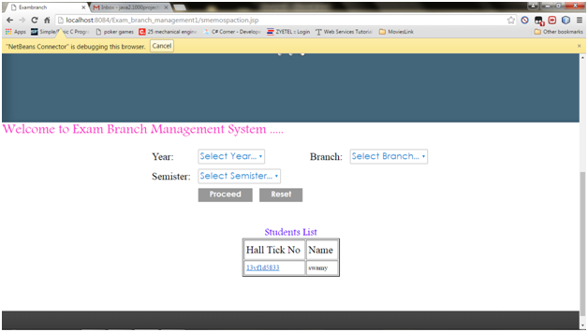

Figure 9

Memorandum:

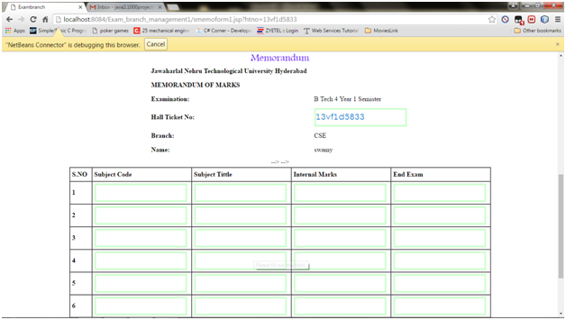

Figure 10

Students Full List:

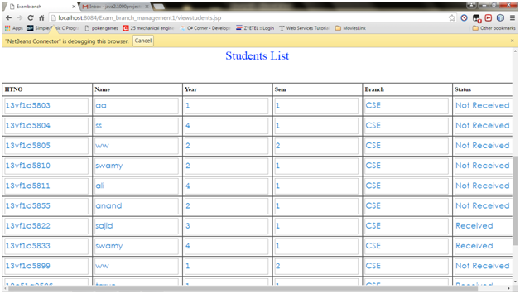

Figure 11

Exam Time Table:

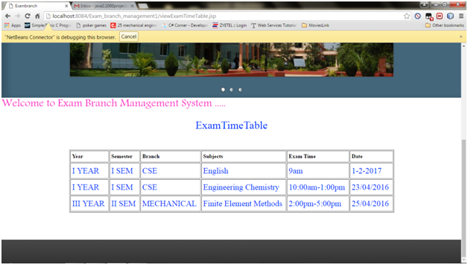

Figure 12

Student Registration Form:

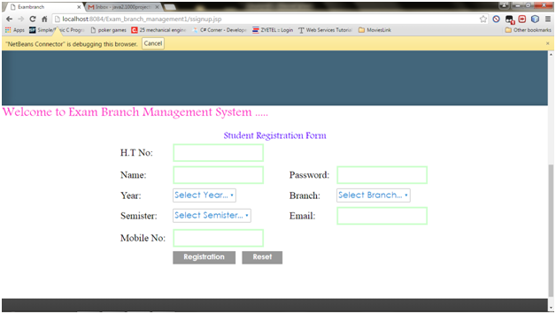

Figure 13

USE CASE:-

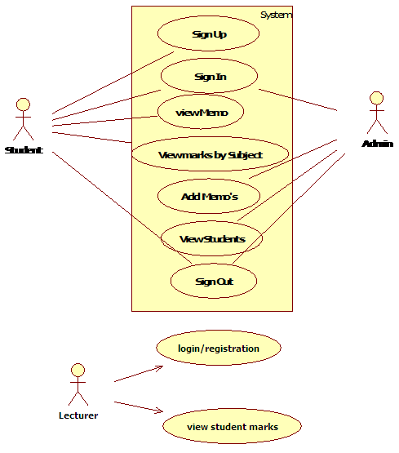

Figure 14

**STUDENT SEQUENCE :-**

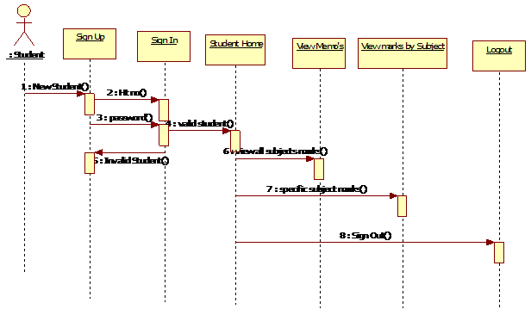

Figure 15

**LECTURER SEQUENCE:-**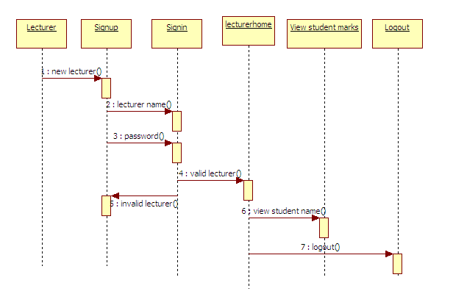

Figure 16

**ADMIN SEQUENCE:-**

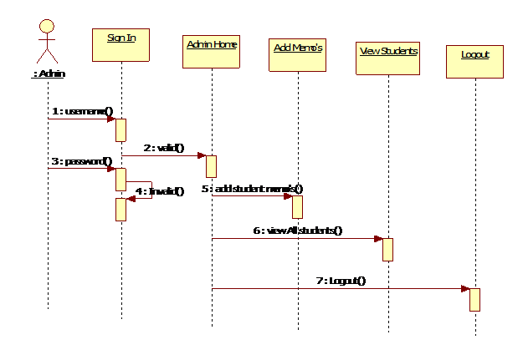

Figure 17

**STUDENT COLLABORATION:-**

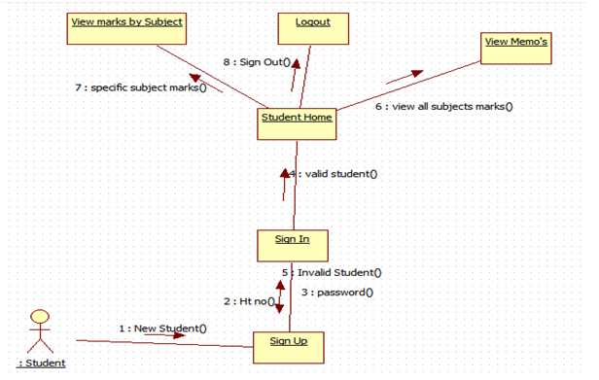

Figure 18

**ADMIN COLLABORATION:-**

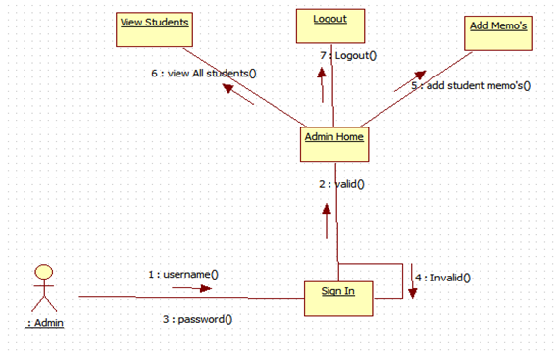

Figure 19

**CLASS:-**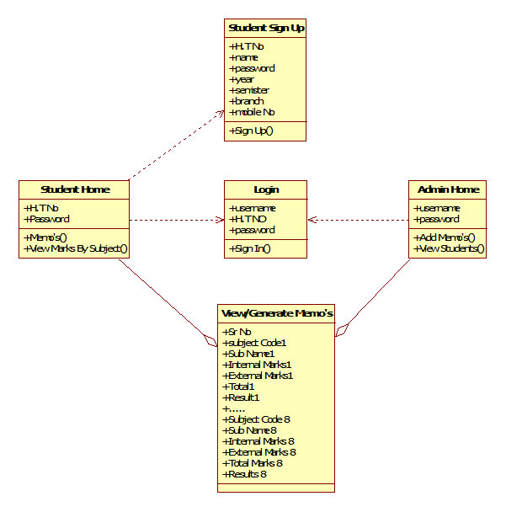

Figure 20

**ER:-**

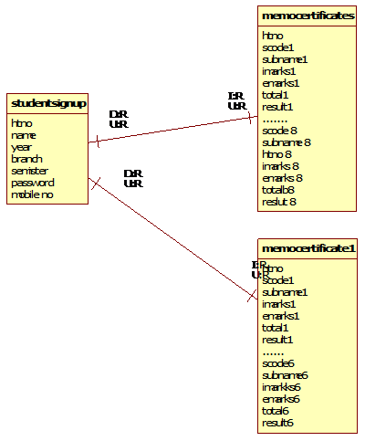

Figure 21

**DEPLOYMENT:-**

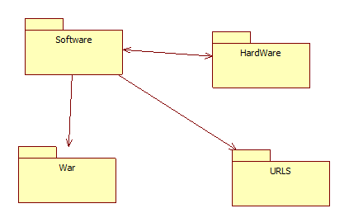

Figure 22

**COMPONENT:-**

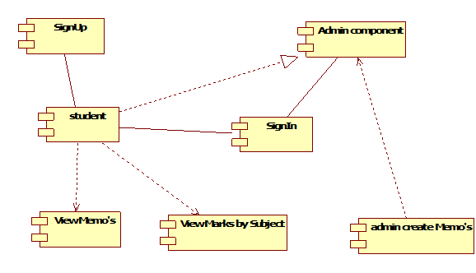

Figure 23

**DATAFLOW:-**

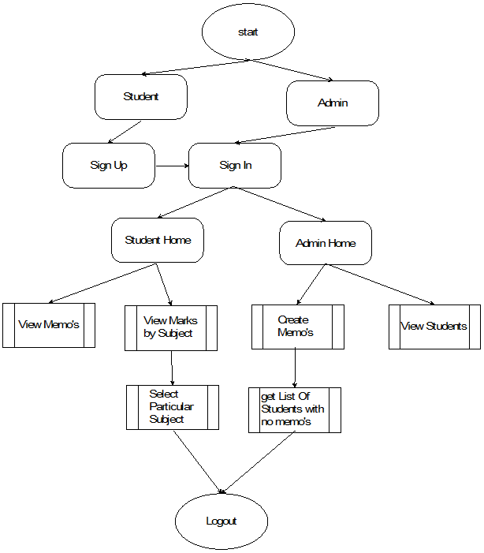

Figure 24

**TESTING**

**5.1 Testing**

Testing is the process of evaluating a system or its component(s) with the intent to find whether it satisfies the specified requirements or not. In simple words, testing is executing a system in order to identify any gaps, errors, or missing requirements in contrary to the actual requirements.

**5.2 UNIT TESTING**

Unit testing is a testing technique using which individual modules are

tested to determine if there are any issues by the developer himself. It is

concerned with functional correctness of the standalone modules

The main aim is to isolate each unit of the system to identify, analyze and fix the defects.

**Unit Testing-Advantages**:

Reduces Defects in the newly developed features or reduces bugs when

changing the existing functionality.Reduces Cost of Testing as defects are captured in very early phase.

Improves design and allows better refactoring of code

Unit Tests, when integrated with build gives the quality of the build as

Well.

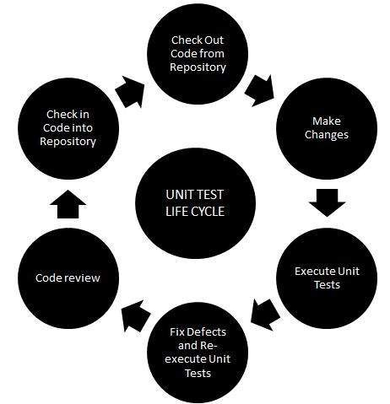

**Unit Testing Techniques**:

2.Black Box Testing Using which the user interface, input and output

are tested.

White Box Testing- used to test each one of those functions behaviour

is tested.

3. Gray Box Testing Used to execute test, risks and assessment methods.

**5.2.1 Black Box Testing**

Black-box testing is a method of software testing that examines the

nationality of an application based on the specifications. It is also known as specification based testing. Independent Testing Team usually performs this type of testing during the software testing life cycle.

method of' test can be applied to each and every level of software testing

unit, integration, system and acceptance testing.

5.2.2 **White Box Testing**

White box testing is a testing technique that examines the program structure and derives test data from the program logic/code. The other names of glass hox testing are clear box testing, open box testing, logic driven testing or path driven testing or structural testing

**White Box Testing Techniques:**

**Statement Coverage**- This technique is aimed at exercising all programming statements with minimal tests.

**Branch Coverage** - This technique is running a series of tests to ensure

that all branches are tested at least once.

**Path Coverage -** This technique corresponds to testing all possible paths

which means that each statement and branch is covered.

**Calculating Structural Testing Effectiveness:**

**Statement Testing(**Number of Statements Excercised by Divided by Total Number of Statements**)**x 100 %

**Branch Testing**(Number of decisions outcomes tested/Total Number of decisionOutcomes) x 100 %

**Path Coverage** (Number paths exercised /Total Number of paths in the program) x 100%**Advantages of White Box Testing:**

1.Forces test developer to reason carefully about implementation.

2.Reveals error in "hidden" code.

3.Spots the Dead Code or other issues with respect to best programming

practices.

**Disadvantages of White Box Testing**:

1. Expensive as one has to spend both time and money to perform white

Box testing.

2. Every possibility that few lines of code are missed accidentally.

3. In-depth knowledge about the programming language is necessary to

perform white box testing.

**5.2.3 Gray Box Testing**

Grey Box testing is testing technique performed with limited information about the internal functionality of the system. Grey Box testers have access to the detailed design documents along with information about requirements.

Grey Box tests are generated based on the state-based models, UML Diagramsor architecture diagrams of the target system.

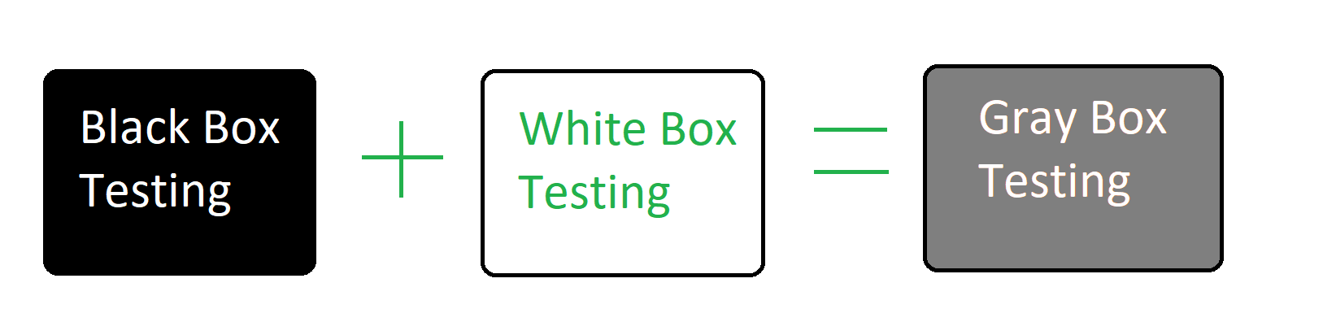

**Gray-box testing Techniques:**

1.Regression testing

2.Pattern Testing

3.Orthogonal array testing

4.Matrix testing

**Benefits:**

1.Grey-box testing provides combined benefits of both white-box and

black-box testing

2.It is based on functional specification, UML Diagrams, Database

Diagrams or architectural view

3. Grey-box tester handles can design complex test scenario more

intelligently

4.The added advantage of grey-box testing is that it maintains the

boundary between independent testers and developers

**Drawbacks:**

1. In grey-box testing, complete white box testing cannot be done due to inaccessible source code/binaries to associate defects when we perform Grey-box testing for a distributed system.

**Best Suited Applications:**

Grey-box testing is a perfect fit for Web-based applications

Grey-box testing is also a best approach for functional or domain testing.

**5.3 INTEGRATION TESTING**

Upon completion of unit testing, the units or modules are to be integrated

which gives raise to integration testing. The purpose of integration testing is to verify the functional, performance, and reliability between the modules that are integrated.

Integration Strategies:

1. Big-Bang Integration

2. Top Down Integration

3. Bottom Up Integration

4. Hybrid Integration

**5.3.1. BIG BANG TESTING**

Big Bang Integration Testing is an integration testing strategy wherein all units are linked at once, resulting in a complete system. When this type of testing strategy is adopted, it is difficult to isolate any errors found, because attention is not paid to verifying the interfaces across individual units.

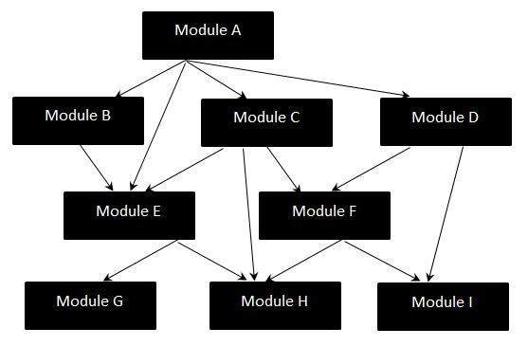

**Disadvantages of Big-Bang Testing:**

1. Defects present at the interfaces of components are identified at very late stage as all components are integrated in one shot.

2.It is very difficult to isolate the defects found.

3.There is high probability of missing some critical defects, which might

Pop up in the production environment.

4.It is very difficult to cover all the cases for integration testing without

sing even a single scenario.

**5.3.2. TOP-DOWN TESTING**

Top-down integration testing is an integration testing technique used in order to simulate the behavior of the lower level modules that are not yet integrated. Stubs are the modules that act as temporary replacement for a called module and give the same output as that of the actual product. The replacement for the called' modules is known as 'Stubs and is also used when the software needs to interact with an external system.

**Stub-Flow Diagram:**

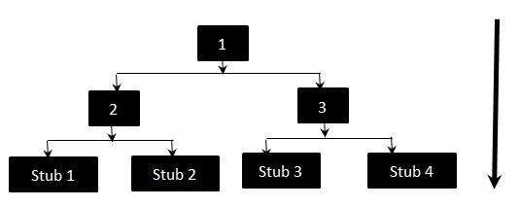

The above diagrams clearly states that Modules 1, 2 and 3 are available for

integration, whereas, below modules are still under development that cannot be integrated at this point of time. Hence, Stubs are used to test the modules

**Testing Approach:**

+Firstly, the integration between the modules 1.2 and 3

+ Test the integration between the module 2 and stub 1 stub 2

+ Test the integration between the module 3 and stub 3.stub 4

**5.3.3. BOTTOM-UP TESTING**

Each component at lower hierarchy is tested individually and then the

components that rely upon these components are tested.

Bottom Up Integration - Flow Diagram

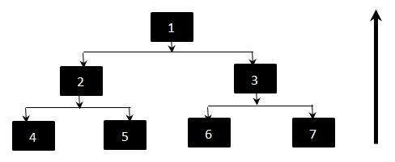

**Testing Approach:**

+ Firstly, Test 4.5.6.7 individually using drivers

+ Test 2 such that it calls 4 and 5 separately. If an error occurs we know that the problem is in one of the modules

+ Test 1 such that it calls 3 and If an error occurs we know that the problem is in 3 or in the interface between 1 and 3

Though Top level components are the most important, yet tested last using

this strategy. In Bottom-up approach, the Components 2 and 3 are replaced by drivers while testing components 4,5,6,7. They are generally more complex than stubs.

**5.3.4. HYBRID TESTING**

We know that Integration Testing is a phase in software testing in which

standalone modules are combined and tested as a single entity. During that

phase, the interface and the communication between each one of those modules are tested. There are two popular approaches for Integration testing which is Top down Integration Testing and Bottom up Integration Testing. In Hybrid Integration Testing, we exploit the advantages of Top-down and Bottom-up approaches. As the name suggests, we make use of both the Integration techniques.

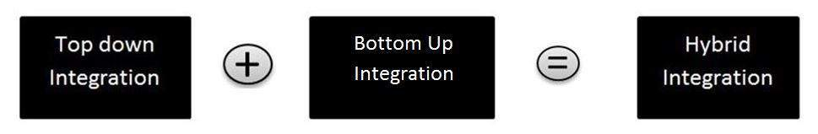

**Hybrid Integration Testing-Features**

1. It is viewed as three layers: viz. The Main Target Layer, a layer above

the target layer and a layer below the target layer.

2 Testing is mainly focused for the middle level target layer and is selected on the basis of system characteristics and the structure of the code.

3. Hybrid Integration testing can be adopted if the customer wants to work

on a working version of the application as soon as possible aimed at

producing a basic working system in the earlier stages of the

development cycle.

**5.4 SYSTEM TESTING**

System Testing (ST) is a black box testing technique performed to evaluate the complete system the system's compliance against specified requirements. In System testing, the functionalities of the system are tested from an end-to-end perspective. System Testing is usually carried out by a team that is independent of the development team in order to measure the quality of the system unbiased, It includes both functional and Non-Functional testing.

**Types of System Tests:**

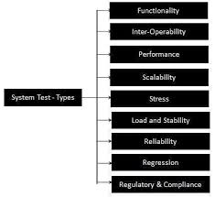

There are different sites to test the websites:

1. Pingdom

2. Google speed test

3. Cloudflare

**5.5 Website Speed Test (Pingdom):**

The website speed will be tested by some online software without

installing, such as Google speed test, Pingdom speed test etc. We selected

pingdom to test your website. Pingdom is a online software which

monitor beite's availability and performance for free and always be the

first to know when your website is down. No installation required.

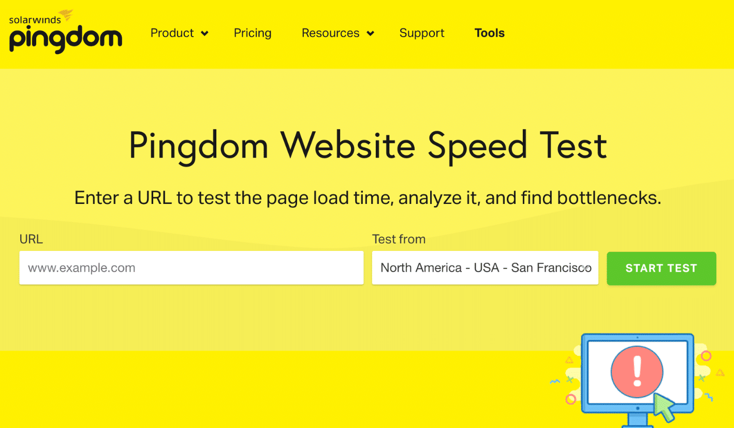

How to test speed in Pingdom:

1.Visit www.tools.pingdom.comsite.

2.There you can test your website speed from different parts of the

World. They are:

Asia

Europe

North America

South America

Australia etc

3.Then enter your website URL in the text box and select the location and click Start test.

For example:

https://mypdl.freevar.com/

**CONCLUSION:**

Exam branch management system makes entire process online where there will be ease of work , is of storing data, better efficiency of data flow ,no data loss.